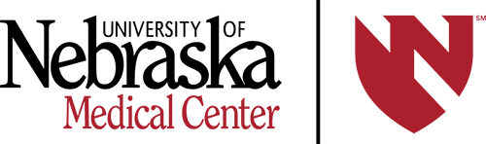UNMC Faculty Club
2025-2026 MEMBERSHIP APPLICATION
and (Member’s Only) Yearbook Information

NAME _________________________ SPOUSE _____________________
ADDRESS ___________________________________________________
___________________________ ZIP CODE _______________
HOME PHONE __________________ CELL PHONE ___________________
E-MAIL (Required) ____________________________________________
UNMC AFFILIATION ___________________________________________
New Members: How did you find out about UNMC Faculty Club? _______________________

MEMBERSHIP CATEGORIES (Indicate One):

_____Membership $50.00
Allows member to participate in all events of the club (interest groups, socials, etc.). Self-pay for Speaker Luncheon(s) and Spring Dinner.

_____Membership with Prepaid Speaker Luncheons $110.00
Gives member access to all the benefits of the club listed above plus 4 prepaid luncheons per year. Self-pay for Spring Dinner.

INTEREST GROUPS (Indicate as many as you would like to be involved with):

_____ Book Club DAY – 2nd Wednesday at 1:00 PM in member’s homes
_____ Book Club EVE – 3rd Thursday by Zoom from 5:30-6:30 PM
_____ Dining Out (Includes Spouses) – 3rd Saturday at 6:00 PM around Omaha
_____ Fine Arts – Day/Eve Trips Dates TBD
_____ Gourmet (Includes Spouses) – Evenings 4-6x/year TBD in member’s homes
_____ Happy Hour (Includes Spouses) – 1st Thursday from 6-7 PM around Omaha
_____ Hiking (Includes Spouses) – 2nd Saturday, time and location TBD
_____ Needle Arts – 1st and 3rd Thursday at 9:30 AM in member’s homes
_____ Newcomers – dates, times, and locations TBD
_____ Pickleball/Badm (Includes Spouses) – 1st Sunday 3-5 PM then Potluck dinner

Please send this form and check payable to “UNMC Faculty Club” for amount indicated above to:
Bunny Pozehl, Club Membership, 8120 S. 194th Street, Gretna, NE 68028

For more information, visit unmc.edu/fwc or E-mail mgallagher@unmc.edu.

