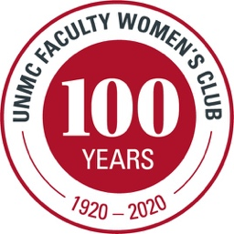 UNMC Faculty Women’s Club
2021-2022 MEMBERSHIP APPLICATION
and (Member’s Only) Yearbook Information

NAME _________________________ SPOUSE _____________________
ADDRESS ___________________________________________________
___________________________ ZIP CODE _______________
HOME PHONE __________________ CELL PHONE ___________________
E-MAIL (Required) ____________________________________________
UNMC AFFILIATION ___________________________________________

MEMBERSHIP CATEGORIES (Indicate One):

_____ Membership $50.00
(Includes participation in all Club events, Interest Group activities,
Socials, Teas, and may attend any Speaker Luncheon with prior $20 payment

_____ Membership with Prepaid Speaker Luncheons $110.00
(Includes Four Speaker Luncheons PLUS all above Club events)

INTEREST GROUPS (Indicate as many as you would like to be involved with):

_____ Book Club DAY – 2nd Wed at 1:00 PM in member’s homes
_____ Book Club EVE – 3rd Thurs by Zoom from 5:30-6:30 PM
_____ Dining Out (Includes Spouses) – 3rd Sat at 6:00 PM around Omaha
_____ Fine Arts – Daytime Trips TBA
_____ Gourmet (Includes Spouses) – Evenings 4-6x/year TBA in member’s homes
_____ Happy Hour (Includes Spouses) – Evenings 4-6x/year
_____ Hiking (Includes Spouses) – 2nd Sat usually AMs around Omaha area
_____ Needle Arts – 1st and 3rd Tues at 9:30 AM in member’s homes
_____ Pickleball/Badminton (Includes Spouses) – 1st Sun from 3:00-5:00 PM TBA

Please send this form and check payable to “FWC” for amount indicated above to:
Pam Hamel (FWC Membership), 3631 S 102nd Street, Omaha, NE 68124

For more information, visit UNMC.edu/FWC or E-mail facultywomensclub@gmail.com

