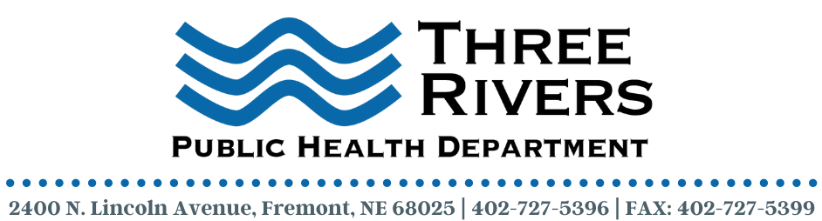
Program Assistant—COVID-19

Description
Three Rivers Public Health Department (3RPHD) is seeking a full-time Program Assistant-COVID-19 to join our dynamic team. Fluent Spanish/English language skills are preferred.

In this position, the Program Assistant will be responsible for providing program, and administrative support to the Public Health Nursing Manger and other public health staff as needed.

3RPHD offers a competitive salary and benefits package along with a work environment that is terrific. Please read below to learn more about this exciting opportunity.

Job/Position Summary:
3RPHD is seeking a Program Assistant this position is responsible for providing support for COVID-19 activities within the health department. Candidate must have a professional demeanor, ability to multi-task and prioritize. Good communications skills and the ability to provide excellent customer service are required. Candidate must be able to work in a fast-paced environment under general supervision. Bilingual English/Spanish communication skills are preferred.

Essential Functions:
- Provide program, administrative support to the Public Health Nursing Manager and other public health staff as needed.
- Provide scheduling assistance.
- Prepare logistical arrangements for meetings, committees, trainings, needs assessments, conferences, and internal/external activities.
- Prepare meeting agendas, meeting minutes and follow-up communication.
- Participate in the development of COVID-19 policies and procedures workgroup.
- Provide daily program support (phone coverage, copying, printing, completing forms, reviewing travel approvals, ensuring incoming external communications get to correct staff member).
- Disseminate materials to internal and external partners and maintain documentation of communication.
- Develop and maintain the official COVID-19 mailing lists.
- Performs day-to-day administrative functions and general office duties including but not limited to word processing, copying, filing, faxing, and answering phones and data entry.
- Attends scheduled department staff and clinical meetings.
- Performs other duties as required.

Employment Qualifications:
- High School graduate or equivalent
- Must be 18 years of age
- Experience working with public health programs
- Knowledge of basic office procedures
- Knowledge of basic office equipment including copier, fax machine, and computer.
- Knowledge of Medical Terminology
- Ability to maintain confidentiality of patient and employee information
- Fluent Bilingual English/Spanish communication skills are preferred.

Deadline to Apply: February 2, 2022

Contact Information:
Three Rivers Public Health Department
C/O Terra Uhing, Executive Director
2400 N Lincoln Avenue
Fremont, NE 68025
terra@3rphd.org
Three Rivers Public Health Department is an equal opportunity employer (EOE).

