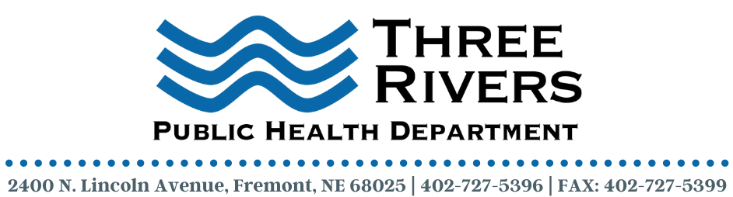
Community Health Program Specialist
Three Rivers Public Health Department (3RPHD) is seeking a full-time Community Health Program Specialist to join our dynamic team. This position will have the opportunity to perform a wide variety of duties including but not limited to engaging, supporting, advocating, and educating community members in overall health and wellness. Additionally, this will include working as a interpret and providing translation services and facilitating community access and improving health outcomes. Fluent Spanish/English language skills are required.

3RPHD offers a competitive salary and benefits package along with a work environment that is terrific. Please read below to learn more about this exciting opportunity.

Job/Position Summary:
3RPHD is seeking a Community Health Program Specialist this position is responsible for providing support for COVID-19 activities within the health department. We are looking for someone who can work with individuals and groups and is a good problem solver. Experience in program implementation, office work, and working with minority communities is highly desired. Must have excellent interpersonal skills and the ability to communicate effectively, both verbally and in writing. Bilingual English/Spanish communication skills are required. Our ideal candidate will hold a bachelor’s degree in a public health-related field or an equivalent combination of experience, education, and training and must be familiar with database and word processing programs, including Microsoft Word, and Excel.

Essential Functions:
- Develop and implement strategies, initiatives, and activities for individuals, families, and
population groups that promote health and prevent disease, injuries, and disabilities in
settings including, but not limited to homes, community organizations, businesses, schools, and the community in general.
- Prepare and disseminate health education materials and information that are accurate,
culturally appropriate and educationally sound, including, but not limited to, brochures,
press releases, media campaigns and postings on social media.
- Gather, organize, interpret, and maintain data for program monitoring, reporting, evaluation, and improvement.
- Plan and conduct workshops, presentations, and training programs for individuals and
groups.
- Write and submit reports in an accurate and timely manner.
- Develops strong ties within target communities in formulating and meeting health education needs.
- This position assists with the development, implementation, and assessment of public health programs and activities.
- Performs other duties as required.

Employment Qualifications:
- High School graduate or equivalent
- Bachelor’s degree preferred
- Two (2) years of community health, public contact, customer, or administrative experience required.
- Two (2) years of experience using MS Office Suite required.
- A valid driver's license and own mode of transportation at the time of hire and throughout employment required.
- Proficient in speaking and translating the assigned minority population language required.
- Knowledge of basic office equipment including copier, fax machine, and computer.
- Ability to maintain confidentiality of patient and employee information
- Fluent Bilingual English/Spanish communication skills are required.

Deadline to Apply: February 2, 2022

Contact Information:
Three Rivers Public Health Department
C/O Terra Uhing, Executive Director
2400 N Lincoln Avenue
Fremont, NE 68025
terra@3rphd.org
Three Rivers Public Health Department is an equal opportunity employer (EOE).

