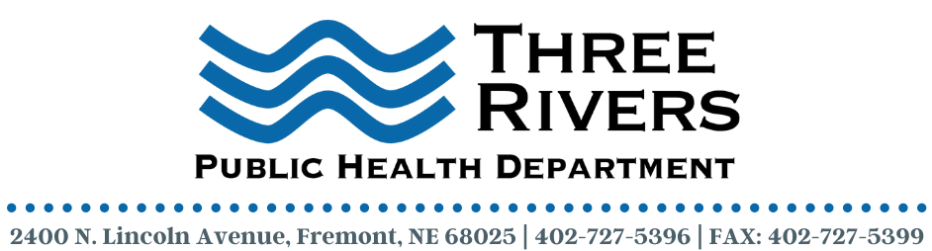
Front Office Receptionist

Description
Three Rivers Public Health Department (3RPHD) is seeking a full-time Receptionist to join our dynamic team. Fluent Spanish/English language skills are required.

In this position, the Receptionist will be responsible for all front office functions including patient relations, appointment scheduling, telephone duties, patient registration, insurance verification, directing patients and visitors. Additionally, this position will provide excellent customer/patient services via phone and in person, referring callers to the appropriate departments.

3RPHD offers a competitive salary and benefits package along with a work environment that is terrific. Please read below to learn more about this exciting opportunity.

Job/Position Summary:
3RPHD is seeking a Receptionist. Candidate must have a professional demeanor, ability to multi-task and prioritize. Good communications skills and the ability to provide excellent customer service are required. Prior experience with an electronic health record (EHR) system is preferable. Responsibilities will include but are not limited to patient registration, patient check in/out, answering telephone (including general health department calls), making appointments, taking patient messages, insurance verification, faxing, filing, and medical records. Candidate must be able to work in a fast-paced environment under general supervision. Bilingual English/Spanish communication skills are required.

Essential Functions:
- Greet patients and visitors in a prompt, courteous, and helpful manner
- Checks in patients, verifies and updates necessary information in the patients electronic health record (EHR)
- Enters all of patient information into the EHR
- Verifies method of payment for service (Medicaid, Medicare, private insurance, private pay, etc.) and collects data and/or co-payment as appropriate.
- Assists in coordination of patient flow to allow the clinic to serve an adequate number of patients as established by grant requirements.
- Must exercise utmost diplomacy and tact to provide excellent customer service for patients; practices confidentiality and privacy protocols in accordance to 3RPHD policies and procedures and HIPAA requirements.
- Maintains patient waiting areas, office files, and front-desk areas in a manner that is organized and neat.
- Completes daily batch reports and cash collections drop following daily operations and ensures reports are forwarded appropriately and timely to accounts receivable.
- Maintains appointment schedule and follows office scheduling policies.
- Communicates with patients and providers.
- Exercises problem-solving and conflict resolution skills when handling patient complaints; refers patient complaints to appropriate designated personnel as needed.
- Performs day-to-day administrative functions and general office duties including but not limited to word processing, copying, filing, faxing, and answering phones and data entry.
- Attends scheduled department staff and clinical meetings.
- Performs other duties as required.

Employment Qualifications:
- High School graduate or equivalent
- Must be 18 years of age
- 2-4 years in a medical setting preferred
- 2-4 years in a customer service setting preferred
- Knowledge of basic office procedures
- Knowledge of basic office equipment including copier, fax machine, and computer.
- Knowledge of Medical Terminology
- Ability to maintain confidentiality of patient and employee information
- Fluent Bilingual English/Spanish communication skills are required.

Deadline to Apply: February 2, 2022

Contact Information:
Three Rivers Public Health Department
C/O Terra Uhing, Executive Director
2400 N Lincoln Avenue
Fremont, NE 68025
terra@3rphd.org
Three Rivers Public Health Department is an equal opportunity employer (EOE).

