****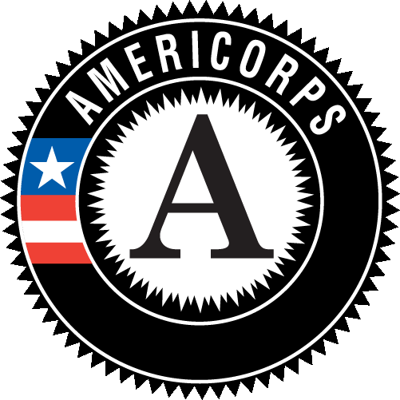**Refugee Empowerment Center**

**ECDC Refugee AmeriCorps Member**

**Position Description**

**Position Title:** Refugee AmeriCorps PC Job Readiness Specialist

**Service Term:** 12 months; Full-time/1700 hours

**Schedule:** 9-5, Monday to Friday

**Reports to**: Preferred Communities Behavioral Health Coordinator

**Service Site**: Refugee Empowerment Center - Omaha, Nebraska

**Position Summary**: This Refugee AmeriCorps position will take place at ECDC's affiliate office, Refugee Empowerment Center (REC), in Omaha, Nebraska. The PC Job Readiness Specialist will support REC’s Preferred Communities (PC) program by helping newly resettled refugees and other eligible individuals gain access to the local job market by providing training and job placement assistance.

**Site Description:** The Refugee Empowerment Center **(**REC) is a community-based non-profit organization whose mission is to resettle refugees from around the world, provide programs to assist into their transition, and promote cultural, educational, social and economic development opportunities in their new communities. REC is an affiliate organization of the Ethiopian Community Development Council, Inc.

**Program Description:** The Ethiopian Community Development Council, Inc. (ECDC) was established in 1983 as a non-profit organization and is headquartered in Arlington, Virginia. ECDC resettles refugees in 16 affiliate and branch offices throughout the country. ECDC’s Refugee AmeriCorps program places ten AmeriCorps members in ten branch offices and affiliates of ECDC across the country to support the work of local agencies in the areas of economic opportunity and education for newly resettled refugees.

Each full-time member will receive a living allowance, health insurance, vacation time off, on-the-job and other training, and CNCS’s AmeriCorps Education Award of $5,730 upon successful completion of service.

**DUTIES AND RESPONSIBILITIES**

**Job Readiness Training and Job Placement (55%)**

* Through group sessions and one-on-one counseling, provide job readiness training to enrolled PC clients on topics such as US workplace culture and behavior, vocational skills, resume writing, conducting job searches, interviewing skills, etc.
* Assist clients with locating and applying for jobs, and with attending interviews.
* Provide individual assessments for clients and follow-up services during eligibility period.
* Track and document services provided in case files and monthly reporting, including clients’ progress in their training program and job placement outcomes.
* Compile and create employment training materials as needed
* Assist clients with transportation for job interviews and trainings, including providing training on how to ride the bus.

**Intensive Case Management Support (40%)**

* Assist PC clients to access, understand, and maintain social benefits, such as SNAP, Medicaid, WIC, etc.
* Provide social adjustment training by coaching clients to develop their social skills, improve their social integration, access community resources, and adapt to life in the US.
* Assist clients to manage their medical conditions, ensuring they have transportation and interpretation and medical appointments and pharmacies.
* Assist clients for medication refills.
* Provide interpretation as needed for behavior health and parenting.
* Manage and update PC case files.

**Additional Duties (5%)**

* Recruit and train volunteers to assist in the PC program.
* Maintain ongoing communication with on-site supervisor and staff.
* Submit all required AmeriCorps timesheets and reports to ECDC national office.
* Attend and participate in on-site and AmeriCorps trainings and professional development, and attend the ECDC National Conference in Arlington, Virginia, in spring 2018 (exact dates TBD).
* Comply with the policies of REC and ECDC’s Refugee AmeriCorps program while carrying out service, and complete at least 1700 service hours during the term.
* Wear the AmeriCorps logo during service hours (AmeriCorps logo gear will be provided).

**QUALIFICATIONS**

* Must be a US citizen, US national, or legal permanent resident.
* Must have a high school diploma or equivalent.
* Fluency in English required; fluency in a second language preferred [Languages such as Burmese, Karen, Nepali, or Arabic].
* Cultural sensitivity and dedication to working directly with diverse communities.
* Previous experience in case management, employment services, refugee services, teaching or training is an asset.
* Computer skills including ability to conduct internet research and accurately use Microsoft Word, Excel, and PowerPoint.
* Must have a car and a valid driver’s license and car insurance.
* Candidates are subject to a National Service Criminal History Check as required by AmeriCorps.
* Former refugees, SIVs, or asylees are encouraged to apply.